

**UNITED INTERNATIONAL UNIVERSITY**

LAB REPORT- 04

Course Name: Control System Laboratory

Course Code: EEE 402/ EEE 4110 (A)

**Submitted To;**

RAHMAN, KALED MASUKUR

PROFESSOR

UIU

**Submitted By;**

Name: Monisha Roy

ID: 021-182-031

Name: Joyanta Debnath

ID: 021-182-032

Date of Submission:

**EXP_04:** The effect of pole location upon the transient response of a second order system and use of SISOTOOL in the Control system design.

**Objective:**

* Investigating the Influence of Pole and Zero Location on Transient Response.
* Studying the Relationship Between Pole Locations, Transient performance and Stability.
* Utilizing SISOTOOL for Control System Design.
* Optimizing Transient Response through Pole Placement.

**PART-A: THE EFFECT OF 3RD POLE LOCATION UPON THE TRANSIENT RESPONSE OF A SECOND ORDER SYSTEM.**

1. **Effect of Additional 3rd Pole;**

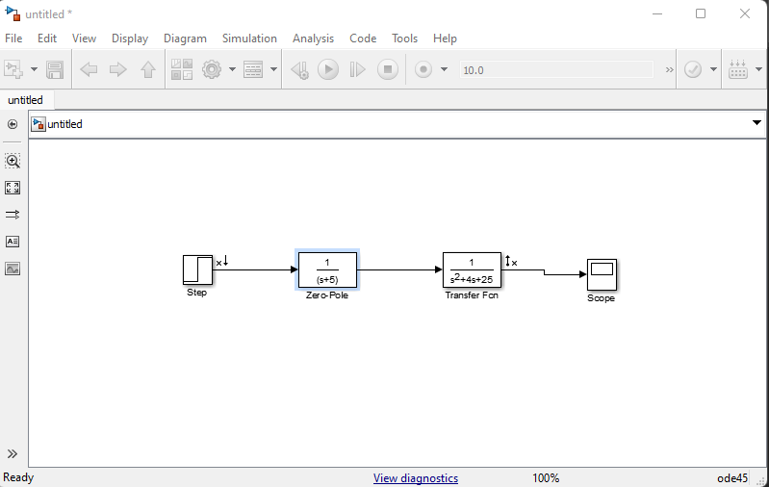

|  |  |  |  |
| --- | --- | --- | --- |
| **Third Pole** | **Experimental** | | |
| **% OS** | **Settling Time** | **Peak Time** |
| **None** | 25.4 | 1.68 | 0.691 |
| **-200** | 25.4 | 1.69 | 0.691 |
| **-20** | 24.5 | 1.73 | 0.737 |
| **-10** | 21.9 | 1.78 | 0.801 |
| **-5** | 14.1 | 1.83 | 0.921 |

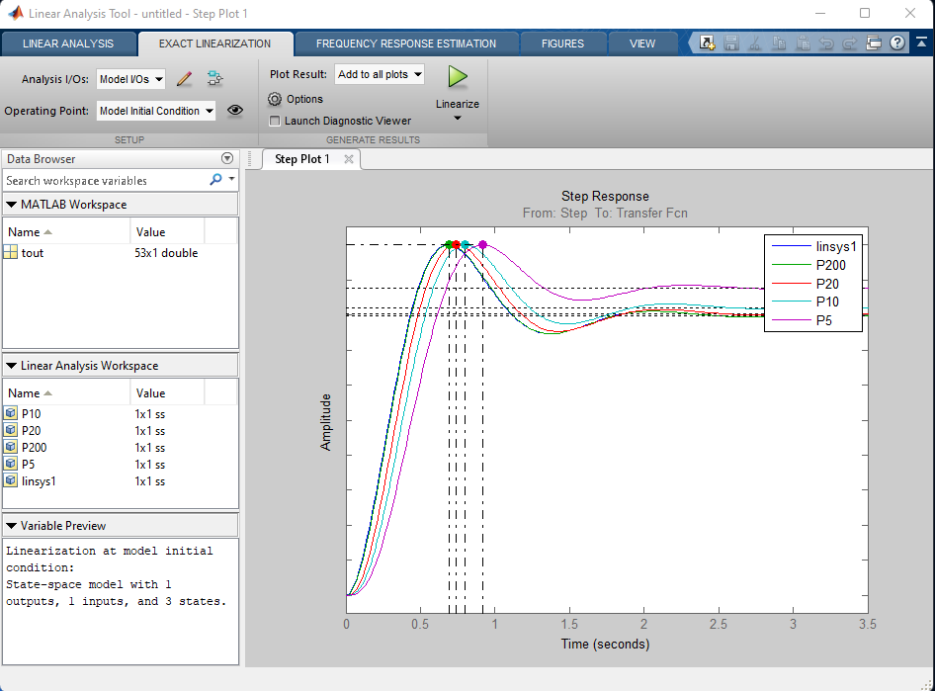

**Comment:** As we can see from the table, gradually changing the additional 3rd pole location, we find increasing values of Ts and Tp while, %OS decreases. Now, from the plot we can say that, for larger values of Ts and Tp we get much slower response and smaller overshoot implies a more stable response.

1. **Effect of Additional Zero;**

|  |  |  |  |
| --- | --- | --- | --- |
| **Additional Zero** | **Experimental** | | |
| **% OS** | **Settling Time** | **Peak Time** |
| **None** | 25.4 | 1.68 | 0.691 |
| **-200** | 25.4 | 1.68 | .691 |
| **-20** | 26.3 | 1.63 | 0.622 |
| **-10** | 29.4 | 1.63 | .576 |
| **-5** | 42.8 | 2.01 | 0.461 |

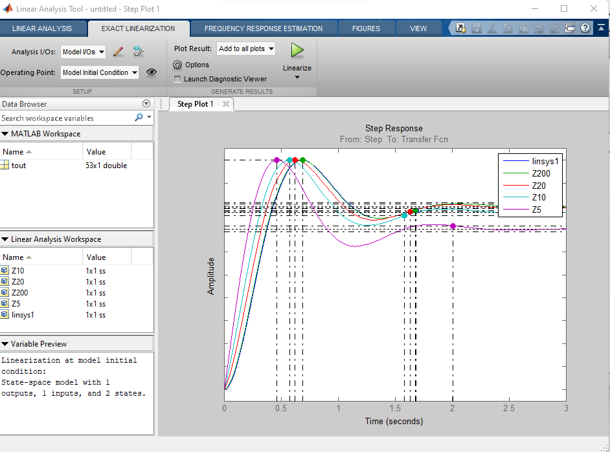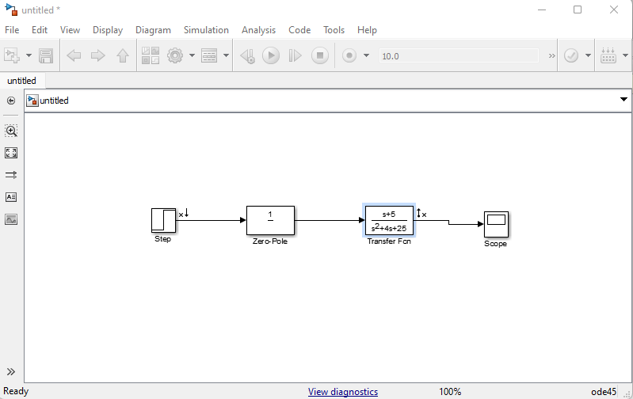

**Comment:** As we can see from the table, changing the additional zero location, we find changes in values of Ts and Tp and %OS. For certain decrease, in values of addition zero location at [-200, -20, -10], Ts and Tp imitates decreasing values but %OS increased gradually. Thus from the plot, the response is much faster and more oscillatory which means, less stable response.

When we put the additional zero location at [-5], we find larger value for Ts and substantially large value for %OS while Tp shows decreasing value. That simplifies from the plot, a slower stabilization but faster response with quicker oscillation meaning, lesser stable response.

1. 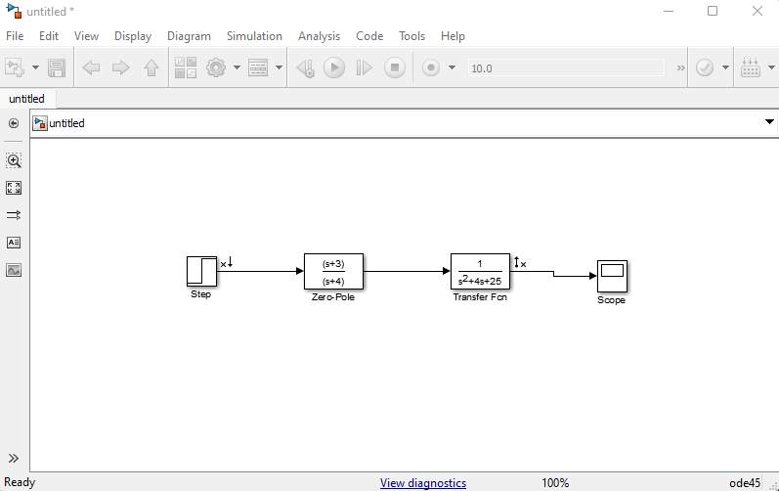**Effect of Pole-Zero Cancellation with small zero;**

|  |  |  |  |
| --- | --- | --- | --- |
| **b** | **a = 3.0** | | |
| **% OS** | **Settling Time** | **Peak Time** |
| **3.0** | 25.4 | 1.68 | 0.691 |
| **3.1** | 26.8 | 1.68 | .668 |
| **3.5** | 31.9 | 1.67 | .645 |
| **4.0** | 37.2 | 2.11 | .622 |

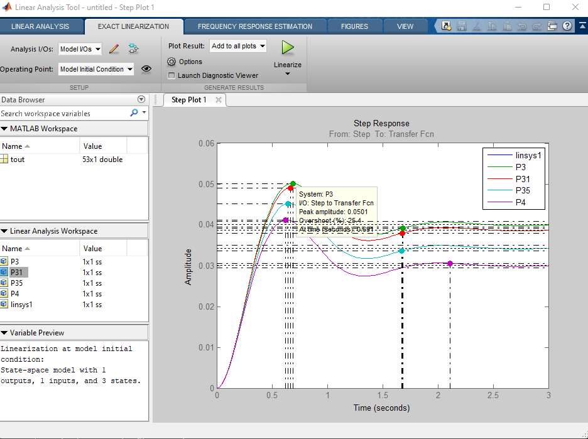

**Comment:** As we can see changing the pole-zero block of the system, from the table we find changes in values of Ts and Tp and %OS. At location [-3, -3.1, -3.5], Ts and Tp gives slightly decreasing values while, %OS increases gradually. From the plot we can say, the response is much faster and more oscillatory which means, less stable response.

At location [-4], we find larger value for Ts and substantially large value for %OS while Tp shows decreasing value. That simplifies from the plot, a slower stabilization but faster response with quicker oscillation meaning, lesser stable response. Also we can see decrease in amplitude of response.

1. **Effect of Pole-Zero Cancellation with Large Zero;**

|  |  |  |  |
| --- | --- | --- | --- |
| **b** | **a = 30.0** | | |
| **% OS** | **Settling Time** | **Peak Time** |
| **30.0** | 25.4 | 1.68 | 0.691 |
| **40** | 25.5 | 1.67 | 0.668 |
| **100** | 25.7 | 1.66 | 0.668 |

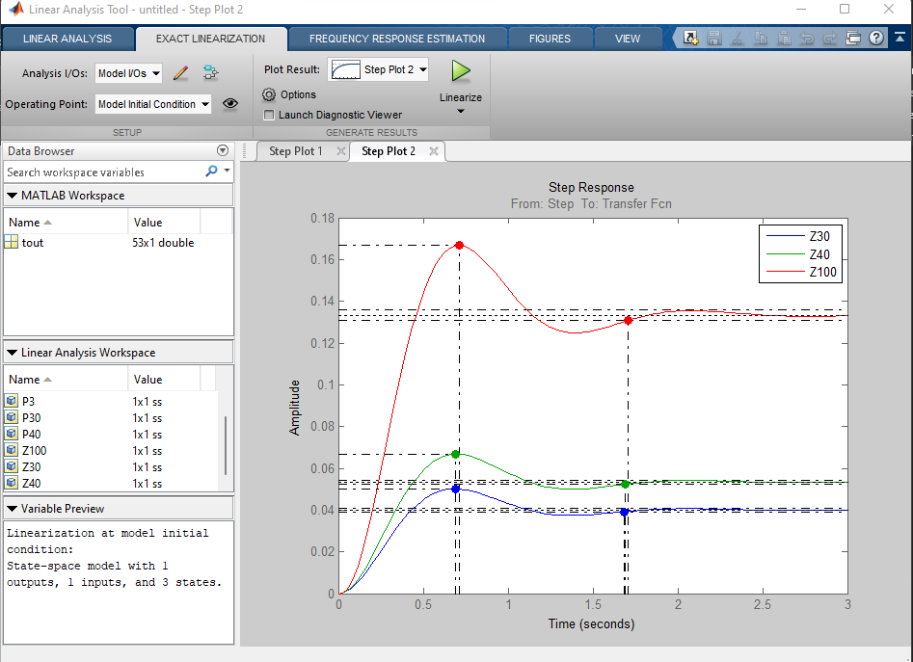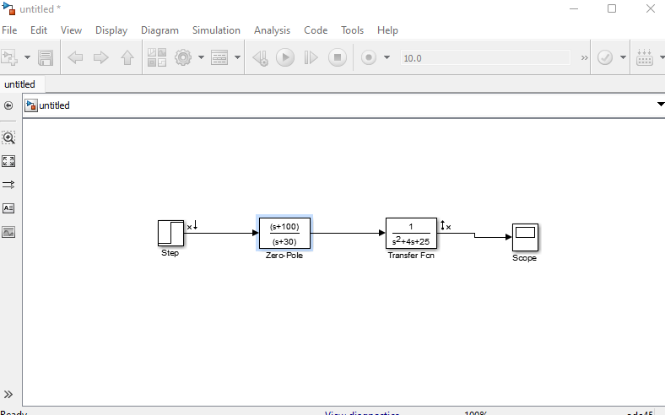

**Comment:** As we can see changing the pole-zero block of the system, from the table we find changes in values of Ts, Tp and %OS. At increasing value of location [-30, -40, -100], Ts, Tp and %OS gives slightly decreasing values. From the plot, we can see faster response, quicker stabilization and oscillation. Where, smaller overshoot implies a more stable response.

**Part-B: USE OF SISOTOOL IN THE CONTROL SYSTEM DESIGN.**

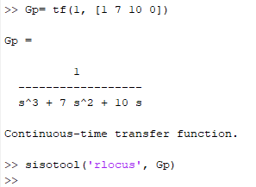

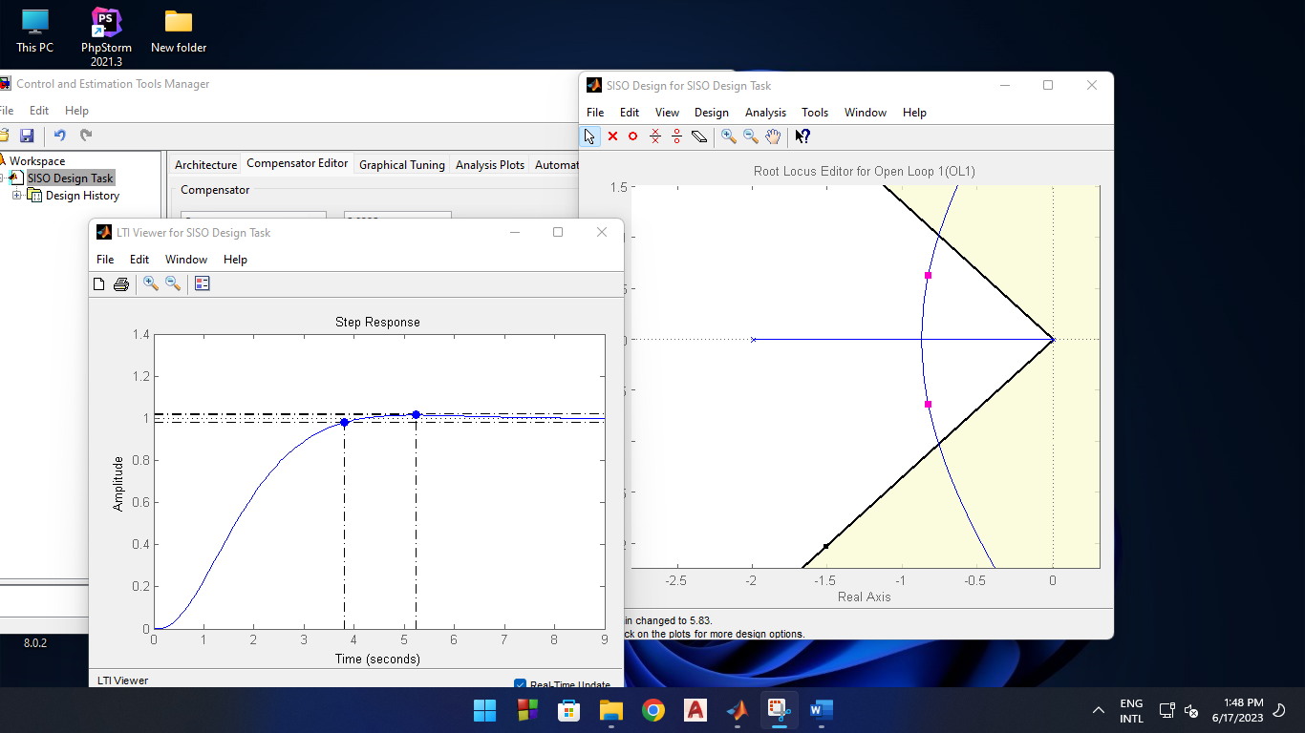

|  |  |  |  |
| --- | --- | --- | --- |
| **Gain K** | 8.9 |  |  |
| **Dominant Complex Poles** | -0.765+-j1.02 | **Third pole** | -5.47 |
| **Natural Frequency** | 1.28 | **Damping Ratio** | 0.6 |
| **Rise Time** | 1.51 | **% Overshoot** | 9.12 |
| **Settling Time** | 4.86 | **Peak Time** | 3.31 |